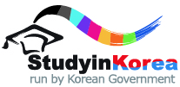
2022 KOREA-JAPAN GOVERNMENT SCHOLARSHIP PROGRAM FOR SHORT-TERM UNDERGRADUATE COURSE
FORM 3 STUDY PLAN

(Please describe your goal of study or detailed study plan including future plan after study in Korea.)
※ One page narrative essay (A4 size, one sided)
※ Typed, not hand written.
※ must be single spaced within ONE page, with the font Times New Roman, size 11. (*11 points)
※ Should be written by the applicant.
※ Should be written in either Korean or English.

