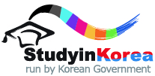
2022 KOREA-JAPAN GOVERNMENT SCHOLARSHIP PROGRAM FOR SHORT-TERM UNDERGRADUATE COURSE
FORM 2 PERSONAL STATEMENT & STUDY PLAN

(Please briefly introduce yourself , write down motivations with which you apply for this program or any other aspects of your background and interests which may help us evaluate your aptitude and passion for study in Korea etc)
※ One page narrative essay (A4 size, one sided)
※ Typed, not hand written.
※ must be single spaced within ONE page, with the font Times New Roman, size 11. (*11 points)
※ Should be written by the applicant.
※ Should be written in either Korean or English.

